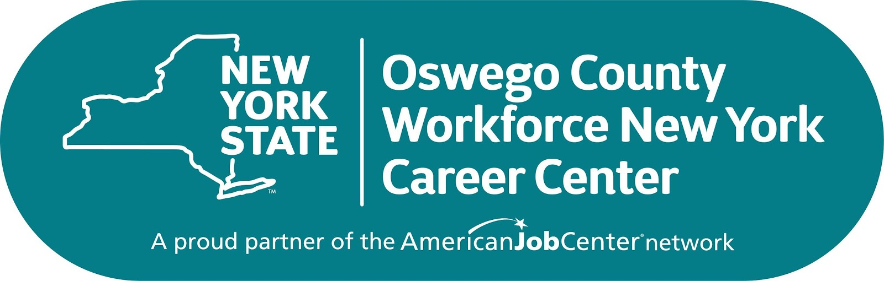

Oswego County Workforce New York

Oswego County Youth Works

Oswego County Employment & Training

Oswego County

**Mexico Office**

100 Spring Street

Mexico, NY 13114

Tel: (315) 963-5512

Fax: (315) 963-5538

TTY: (315) 963-5055

Hours of Operation:

Monday, 8:30am - 6:00 pm

Tuesday - Friday, 8:30am - 4:00 pm

**Fulton Office**

200 North Second Street

Fulton, NY 13069

Tel: (315) 591-9000

Fax: (315) 591-9047

TTY: (315) 591-9247

Hours of Operation:

Monday - Friday, 8:30am - 4:30 pm

**WE OFFER**

* **Job listings and employer recruitments**
* **Internet, computers, and printer access**
* **Fax and copy machines, bond paper for resumes**
* **Phone bank including TTY access**
* **Labor market and in-demand occupation information**

**Our Career Centers**

**offer the tools to make your job search a success!**

Oswego County Workforce New York

**Oswego County Workforce New York is an equal**

**opportunity employer/program. Auxiliary aids are**

**available upon request to individuals with disabilities.**

**DEVELOP A CAREER PLAN**

* **Skills identification and career exploration**
* **Upgrading skills using Metrix Learning System with free access to thousands of online courses**
* **You may qualify for financial assistance for one of the following:**
* **On-the-Job Training (OJT) – earn while you learn**
* **Training Scholarship - financial assistance for educational programs or short-term vocational classes**
* **Supportive Services – work clothes, transportation expenses, childcare, and more**